**Documentation of steps taken to download papers**

Websites

JPE: <https://www-journals-uchicago-edu.proxy.uchicago.edu/loi/jpe>

Go to EBSCO Host: <https://web-p-ebscohost-com.proxy.uchicago.edu/>

JN "Quarterly Journal of Economics" + set Published Date: 20150101-

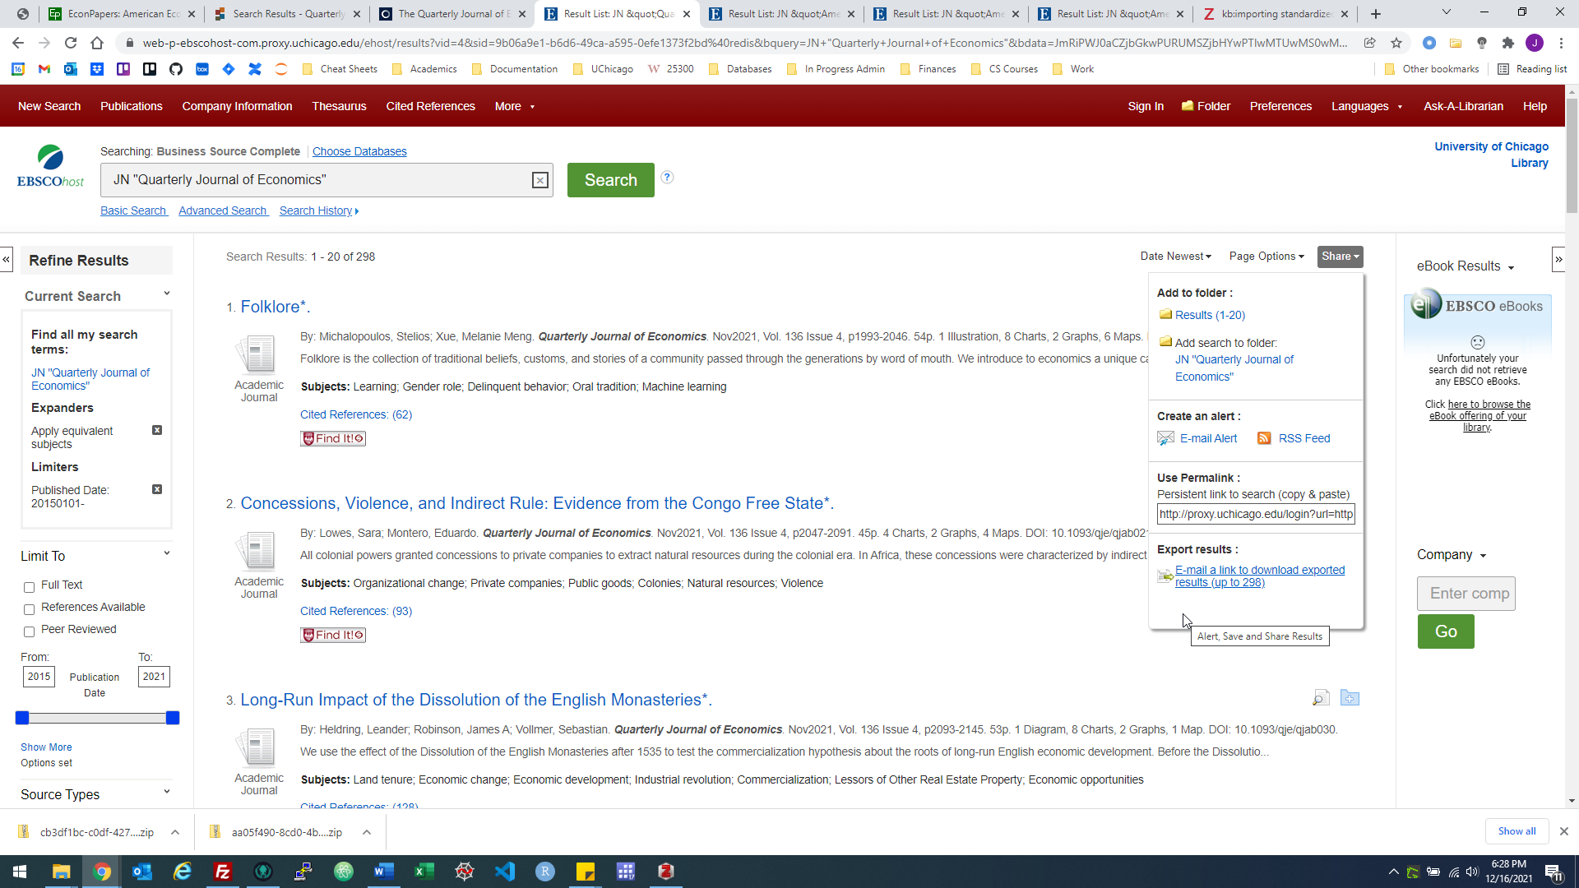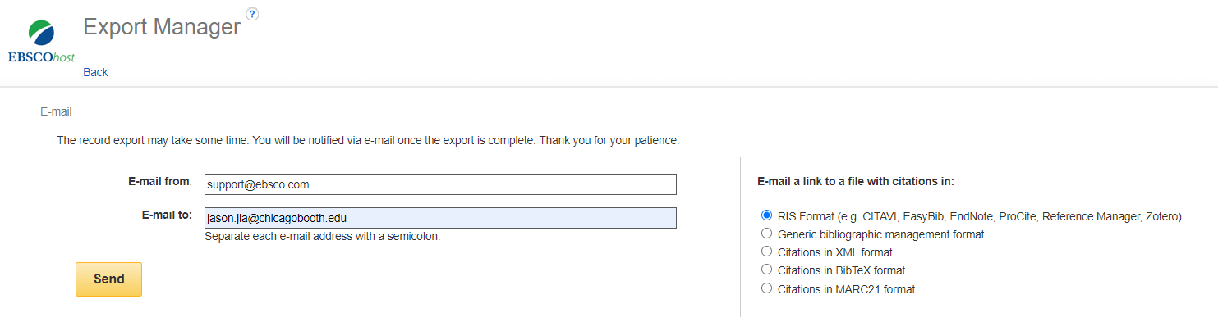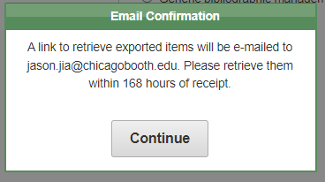

Persistent Links to Searches

Name Page Options

1-5 of 5

Page: 1

Select / deselect all Delete Items

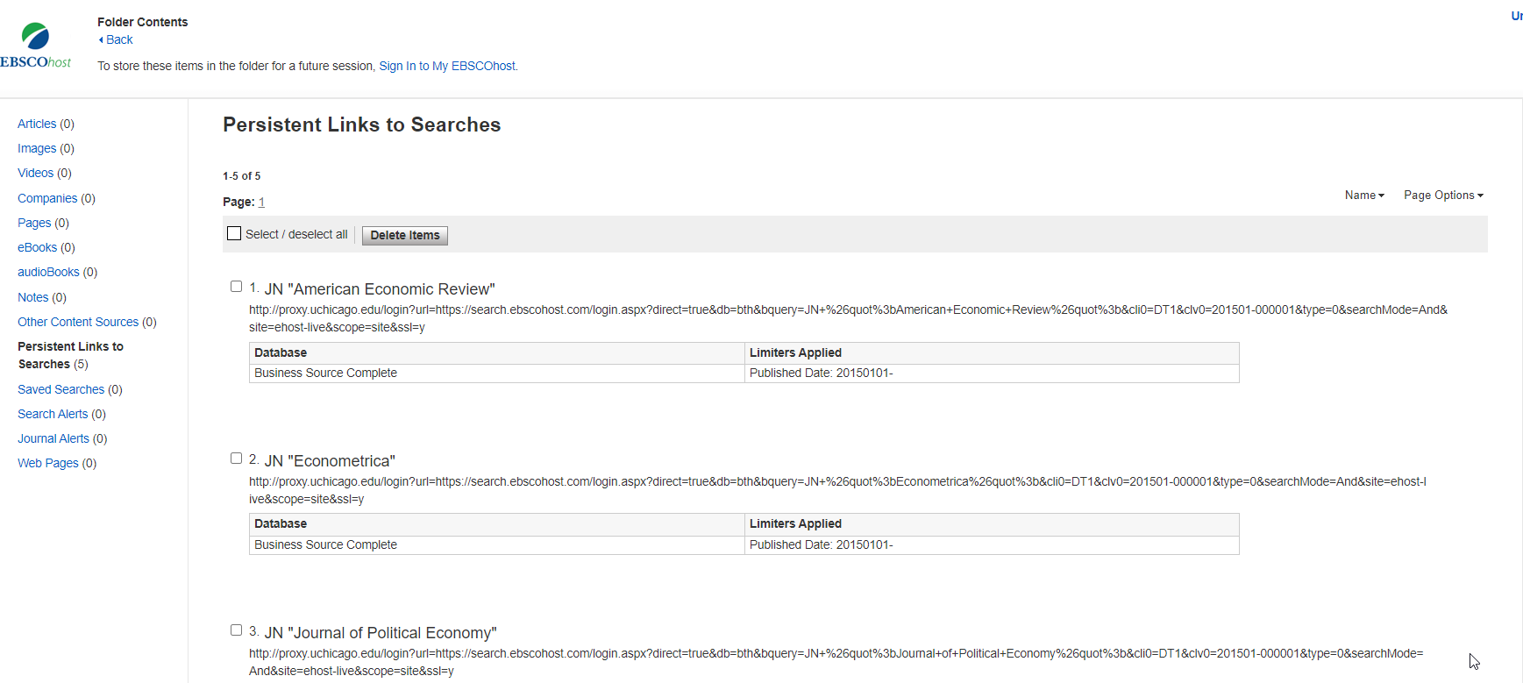

1.

JN "American Economic Review"

http://proxy.uchicago.edu/login?url=https://search.ebscohost.com/login.aspx?direct=true&db=bth&bquery=JN+%26quot%3bAmerican+Economic+Review%26quot%3b&cli0=DT1&clv0=201501-000001&type=0&searchMode=And&site=ehost-live&scope=site&ssl=y

Database Limiters Applied

Business Source Complete Published Date: 20150101-

2.

JN "Econometrica"

http://proxy.uchicago.edu/login?url=https://search.ebscohost.com/login.aspx?direct=true&db=bth&bquery=JN+%26quot%3bEconometrica%26quot%3b&cli0=DT1&clv0=201501-000001&type=0&searchMode=And&site=ehost-live&scope=site&ssl=y

Database Limiters Applied

Business Source Complete Published Date: 20150101-

3.

JN "Journal of Political Economy"

http://proxy.uchicago.edu/login?url=https://search.ebscohost.com/login.aspx?direct=true&db=bth&bquery=JN+%26quot%3bJournal+of+Political+Economy%26quot%3b&cli0=DT1&clv0=201501-000001&type=0&searchMode=And&site=ehost-live&scope=site&ssl=y

Database Limiters Applied

Business Source Complete Published Date: 20150101-

4.

JN "Quarterly Journal of Economics"

http://proxy.uchicago.edu/login?url=https://search.ebscohost.com/login.aspx?direct=true&db=bth&bquery=JN+%26quot%3bQuarterly+Journal+of+Economics%26quot%3b&cli0=DT1&clv0=201501-000001&type=0&searchMode=And&site=ehost-live&scope=site&ssl=y

Database Limiters Applied

Business Source Complete Published Date: 20150101-

5.

JN "Review of Economic Studies"

http://proxy.uchicago.edu/login?url=https://search.ebscohost.com/login.aspx?direct=true&db=bth&bquery=JN+%26quot%3bReview+of+Economic+Studies%26quot%3b&cli0=DT1&clv0=201501-000001&type=0&searchMode=And&site=ehost-live&scope=site&ssl=y

Database Limiters Applied

Business Source Complete Published Date: 20150101-

1-5 of 5

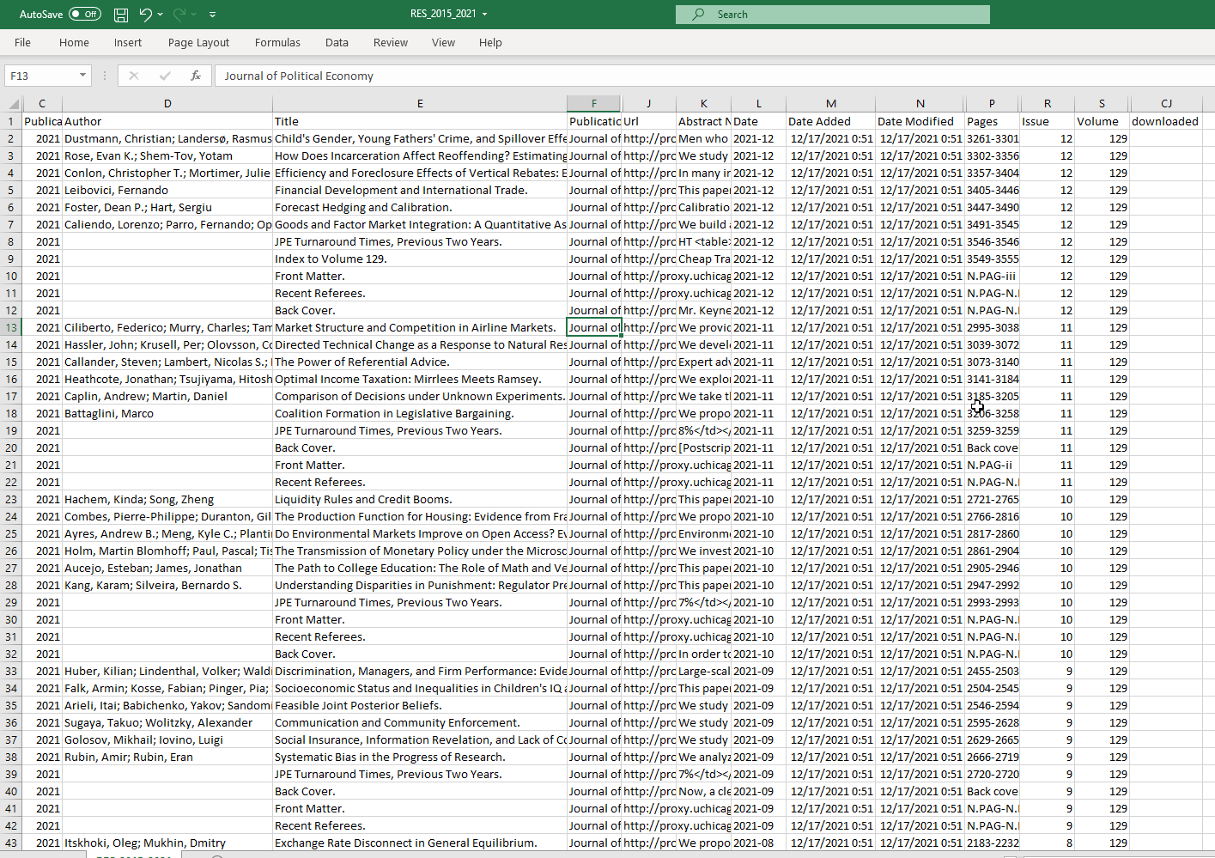

Is paper if author entry is non-empty – a paper must have an author. Articles that are not papers (e.g. front matter) will have an empty author entry.

Copy filtered table to a new sheet

Add the filename once the paper is downloaded.

Working screen:

Errata/Corrigenda (entries with authors but no papers), comments/responses (on papers), research notes, Nobel Lectures (e.g. Strategic Analysis of Auctions, Robert B. Wilson, Econometrica, 2021, March, <https://onlinelibrary-wiley-com.proxy.uchicago.edu/toc/14680262/2021/89/2> , the speeches by Banerjee, Duflo and Kremer on AER 2020 July) are deleted on the new sheet when seen. The initial sheet is not updated to reflect this.

Comments:

2019 Miao, Jianjun; Shen, Zhouxiang; Wang, Pengfei Monetary Policy and Rational Asset Price Bubbles: Comment. 2019-05 1969-1990 aer.20180145

However, special editions are not removed (e.g. JPE, Special Edition on Chicago). Review Essays.

PAPERS IN HONOR OF JAMES J. HECKMAN

2019 Nordhaus, William Climate Change: The Ultimate Challenge for Economics. 2019-06 1991-2014 aer.109.6.1991

2019 Nordhaus, William D. Can We Control Carbon Dioxide? (from 1975). 2019-06 2015-2035 aer.109.6.2015

Preface.

JPE Limit: 200 per session, need to email

AER: 100 per session, auto renewal in 1h

E.g. The New Tools of Monetary Policy†

By Ben S. Bernanke* AER 2020 04

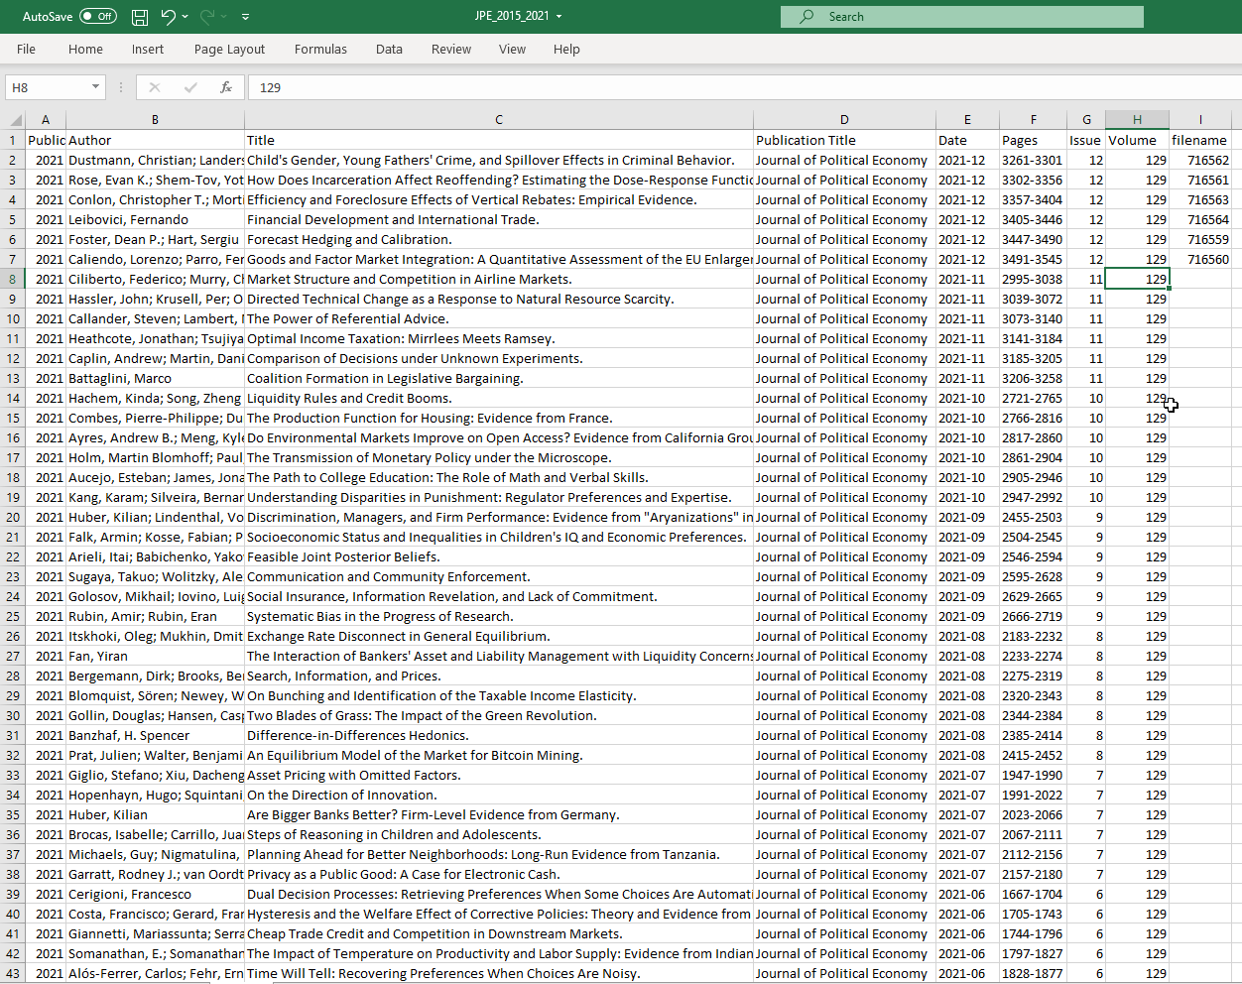

Econometrica - 2019 - Carroll - Strategic Communication With Minimal Verification -> notes but downloaded

AEA shorter papers downloaded

AER: did not download May 2015, May 2016 and May 2017 issues, which contain papers from AEA Papers and Proceedings instead.